Byzantine Faults
# Source: AI Source: Provided by: [Data Path: Persons Table -> ID Column: 1, Name_En Column: Motasem Essam] -> From: [ChatGPT] on [1/21/2026]
Byzantine Faults are a special and critical type of fault in Real-Time Systems (RTS) and distributed systems, where components may fail in arbitrary or malicious ways, making them very difficult to detect and handle.

Definition
# Source: AI Source: Provided by: [Data Path: Persons Table -> ID Column: 1, Name_En Column: Motasem Essam] -> From: [ChatGPT] on [1/21/2026]
A Byzantine fault occurs when a component (hardware or software) behaves inconsistently or unpredictably, potentially giving different incorrect outputs to different parts of the system.
- Named after the “Byzantine Generals Problem” in distributed computing.
- Faults may be due to malicious attacks, software bugs, or unpredictable hardware behavior.

Key Features
# Source: AI Source: Provided by: [Data Path: Persons Table -> ID Column: 1, Name_En Column: Motasem Essam] -> From: [ChatGPT] on [1/21/2026]
- Arbitrary Behavior – A faulty component may send conflicting information to different nodes.
- Difficult to Detect – Cannot be detected simply by checking for “failure” or absence of response.
- Critical in Distributed Systems – Especially in safety-critical real-time systems where multiple nodes must agree.
- Requires Consensus Mechanisms – Special protocols like Byzantine Fault Tolerant (BFT) algorithms are used to tolerate such faults.

Examples
# Source: AI Source: Provided by: [Data Path: Persons Table -> ID Column: 1, Name_En Column: Motasem Essam] -> From: [ChatGPT] on [1/21/2026]
- A sensor in a distributed system sending different readings to different controllers.
- A network node or process giving wrong results intermittently.
- Malicious software in a distributed control system sending inconsistent commands.

Impact
# Source: AI Source: Provided by: [Data Path: Persons Table -> ID Column: 1, Name_En Column: Motasem Essam] -> From: [ChatGPT] on [1/21/2026]
- Can lead to system-wide incorrect decisions.
- Hard to recover without redundancy and consensus algorithms.
- In real-time systems, can violate safety-critical deadlines and constraints.

Handling Byzantine Faults
# Source: AI Source: Provided by: [Data Path: Persons Table -> ID Column: 1, Name_En Column: Motasem Essam] -> From: [ChatGPT] on [1/21/2026]
- Redundancy – Multiple components performing the same task.
- Consensus Protocols – Nodes agree on the correct value despite faulty nodes.
- Error Detection Codes – Helps detect inconsistency in outputs.

Applications / Relevance
# Source: AI Source: Provided by: [Data Path: Persons Table -> ID Column: 1, Name_En Column: Motasem Essam] -> From: [ChatGPT] on [1/21/2026]
- Aerospace and avionics systems
- Distributed control systems in nuclear plants or industrial automation
- Blockchain and distributed ledger systems
- Critical fault-tolerant real-time embedded systems

Quick Comparison of Fault Types
# Source: AI Source: Provided by: [Data Path: Persons Table -> ID Column: 1, Name_En Column: Motasem Essam] -> From: [ChatGPT] on [1/21/2026]
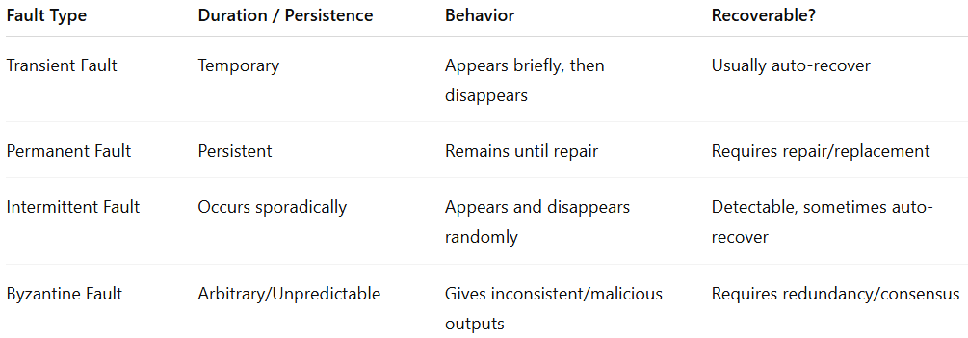
Fault Type | Duration / Persistence | Behavior | Recoverable?
Transient Fault | Temporary | Appears briefly, then disappears | Usually auto-recover
Permanent Fault | Persistent | Remains until repair | Requires repair/replacement
Intermittent Fault | Occurs sporadically | Appears and disappears randomly | Detectable, sometimes auto-recover
Byzantine Fault | Arbitrary/Unpredictable | Gives inconsistent/malicious outputs | Requires redundancy/consensus

